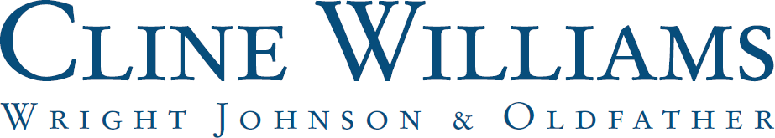

Cline Williams is honored to announce its rankings in the Chambers USA 2023 Guide. The publication recognized 9 attorneys and 3 of the firm's practice groups. Our Litigation: General Commercial practice group is ranked in the top-tier Band 1 and our attorneys are ranked across seven practice areas.

Chambers annually ranks attorneys and law firms based on in-depth research and interviews with their clients and peers. The qualities in which rankings are assessed include technical legal ability, client service, professional conduct, diligence, commercial vision, and business understanding.

The Cline Williams practice groups included in the 2023 Chambers USA Guide:

Band 1
Litigation: General Commercial
Band 2
Corporate/Commercial
Band 3
Labor & Employment

The Cline Williams attorneys included in the 2023 Chambers USA Guide: Mark A. Christensen – Litigation: Mediators
Susan K. Sapp – Insurance and Litigation: General Commercial Rochelle A. Mullen – Corporate/Commercial
Trenten P. Bausch – Litigation: General Commercial Michael C. Pallesen – Corporate/Commercial Richard P. Jeffries – Litigation: General Commercial Andre R. Barry – Litigation: General Commercial
Keith T. Peters – Employee Benefits & Executive Compensation Tara A. Stingley – Labor & Employment

