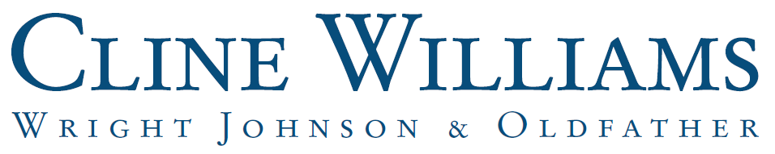



JESSICA K. ROBINSON
jrobinson@clinewilliams.com
(402) 474-6900

Practice Areas:
- Administrative Litigation
- Business Litigation
- Constitutional and Governmental Litigation
- Intellectual Property Litigation

Practice Emphasis:
Jessica focuses her practice on complex civil litigation with an emphasis on matters involving high-volume electronic discovery, procedurally sophisticated disputes, and strategic case management. She guides businesses, public entities, and individuals through litigation where control of the record and disciplined discovery strategy are critical to success.

Jessica’s experience includes managing discovery in cases involving hundreds of thousands of documents, negotiating and defending expansive Rule 30(b)(6) depositions, and briefing dispositive motions in federal and state court. She regularly handles disputes involving government entities, contract and bid controversies, and procedurally technical matters like mandamus cases and sovereign immunity defenses.

Clients appreciate Jessica’s ability to distill large volumes of information into clear options and her direct, practical guidance. She works closely with corporate executives, in-house counsel, other attorneys, and individual clients, prioritizing regular communication, thoughtful strategy, and efficient resolution.

Jessica also advises colleagues on electronic discovery and information governance issues and is developing professional presentations on these topics, including the intersection of litigation and emerging technologies.

Admitted to Practice:
Nebraska
United States District Court for the District of Nebraska
United States District Court for the District of Colorado

Education:
University of Nebraska, J.D., with highest distinction, 2021
Valley City State University, B.S., summa cum laude, 2017

Other Experience/Achievements:
- Graduated first in class, University of Nebraska College of Law, 2021
- Order of the Coif
- Executive Editor, Nebraska Law Review, 2020-2021
- Nebraska State Bar Foundation Silver Quill Award, 2019
- Published: Who Wears the Pants? Everyone Who Wants to: Expanding Price Waterhouse Sex Stereotyping to Cover Employer-Mandated Sex-Differentiated Dress and Grooming Codes in the Eighth Circuit, 99 Neb. L. Rev. 769 (2020)

4884-2703-1787, v. 2

