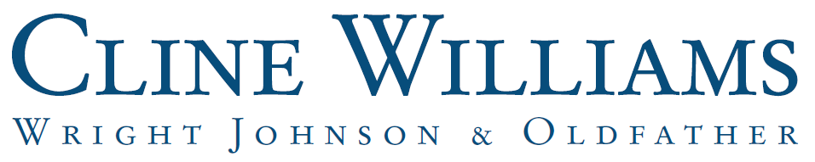

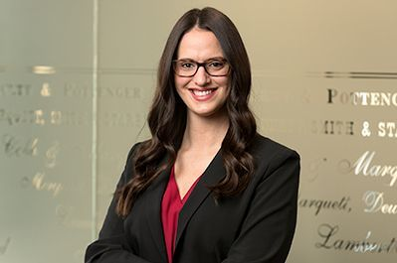

ALISON JANECEK BORER
aborer@clinewilliams.com
(402) 474-6900

Practice Areas:
- Business Organizations
- Real Estate & Environmental Law
- Lending and Finance

Practice Emphasis:
Alison’s practice focuses on real estate transactions, including real estate development, zoning and land use matters, tax increment financing, the purchase and sale of real property, and commercial leasing. Alison also represents clients on a variety of business transactions.

Admitted to Practice:
Nebraska
United States District Court for the District of Nebraska

Education:
University of Nebraska, J.D., with high distinction, 2017
University of Denver, B.S.B.A., cum laude, 2014

Other Experience/Achievements:

- Listed: Super Lawyers Great Plains Rising Star, 2025 and 2026
- Executive Editor, Nebraska Law Review, 2016-2017
- Order of the Coif

