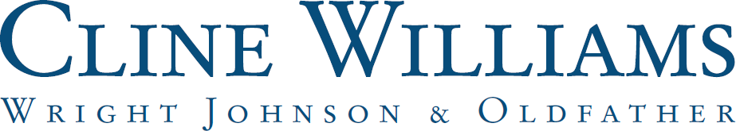

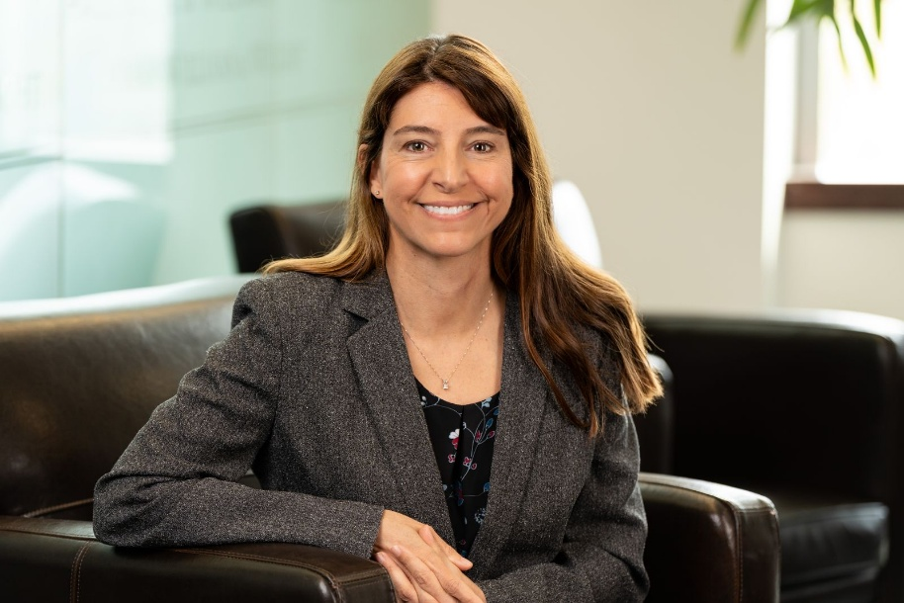

ALISON D. BASYE
abasye@clinewilliams.com
(402) 397-1700

Practice Areas:
- Labor and Employment

Practice Emphasis:
Ali was formerly in the General Counsel’s Office at the University of Nebraska. Her practice involves helping clients problem-solve their trickiest employment issues. She advises clients on a variety of employment matters, including hiring, firing, disciplinary warnings, accommodation plans, employee handbooks, and separation agreements. Ali has experience in a wide range of employment laws including Title VII, ADA, ADEA, FMLA, FLSA, and Nebraska law. Ali has represented clients before the EEOC, NEOC, Nebraska Department of Labor, and other agencies.

Admitted to Practice:
Nebraska
United States District Court for the District of Nebraska (confirm this is active)

Education:
Creighton University School of Law, J.D., magna cum laude, 2005
Marquette University, B.A., Political Science and Theater Arts, magna cum laude, 2001
Other Experience/Achievements:
- Associate General Counsel, University of Nebraska, 2010-2019
- University of Nebraska-Lincoln HR Partners Award, 2012
- Creighton Law Review, 2003-2005
- Creighton Trial Team, 2005
- Creighton Moot Court Travelling Team, 2004
- CALI Excellence for the Future Awards in Property, Legal Writing, and Conflicts of Laws

Publications:
- Author, A Bad Day: The Nebraska Supreme Court Refuses to Recognize Claims for Misrepresented Paternity in Day v. Heller, 37 Creighton L. Rev. 197 (2003-2004)

Other:
- Co-founder, Nebraska PANS/PANDAS Coalition
- Testified in favor of LB 762 before the Banking, Commerce, and Insurance Committee of the Nebraska Legislature, February 17, 2026 (Approved by the Governor, April 14, 2026)

